**PUBLIC TRANSPORT OPTIMIZATION:**

**(**Data analysis):

Analyzing the state of public transport in India from 2010 to the present involves an in-depth study, which cannot be fully covered in a text-based response. However, I can provide you with a simplified narrative analysis based on available knowledge up to 2021. Please note that for an up-to-date and comprehensive analysis, you would need access to current data and detailed research.

**Analysis of Public Transport in India (2010-2021):**

1. **Growth of Metro Systems**: India has seen a significant expansion of metro rail systems in major cities like Delhi, Mumbai, Bangalore, and Chennai. These have helped reduce traffic congestion and provided a faster mode of urban transportation.

2. **Expansion of Bus Networks:**Bus transport continues to be a critical mode of public transport. The Jawaharlal Nehru National Urban Renewal Mission (JNNURM) and Smart Cities Mission have played a role in improving bus services in several cities.

3. **High-Speed Rail (HSR):** The Indian government initiated several HSR projects to connect major cities, promising faster, more efficient, and sustainable transportation.

**4. Challenges in Bus Transportation:** While buses are a lifeline for many, challenges such as over-crowding, poor maintenance, and safety issues remain. Improving the quality and coverage of bus services remains a significant challenge.

**5. Railway Infrastructure:** The Indian Railways underwent modernization and electrification efforts, enhancing connectivity and speed. The Dedicated Freight Corridor (DFC) project aims to improve freight transport efficiency.

**6. Impact of Urbanization:** Rapid urbanization has increased the demand for public transportation. However, the growth in vehicle ownership has also led to increased traffic congestion in many urban areas.

**7. Financial Sustainability:** Many public transport systems continue to rely on government subsidies. Finding a sustainable financial model is crucial for long-term viability.

**8. Sustainability and Environmental Impact:** Environmental concerns have led to a greater focus on sustainability and cleaner technologies in public transport.

**9. Digital Transformation:** The advent of smartphone apps for booking tickets, checking schedules, and real-time tracking has made public transport more accessible and convenient.

**10. COVID-19 Impact:**The COVID-19 pandemic disrupted public transport as lockdowns were enforced, and people hesitated to use crowded public transit. Recovery efforts were essential to restore services.

**11. Last-Mile Connectivity:** Improving the connectivity between public transport modes and destinations remains a priority, ensuring ease of use for commuters.

**12. Integration of Transport Modes:** Efforts have been made to integrate various modes of transportation within a city to create a seamless, intermodal system.

**13. Safety and Security:** Ensuring the safety of passengers, particularly women and vulnerable groups, remains a concern.

\*\***Future Prospects:\*\***

The future of public transport in India may see further expansion of metro systems, the success of high-speed rail projects, and a shift towards electric and sustainable transport. The government's policies and investments will play a crucial role in shaping the future of public transportation. Additionally, addressing the environmental impact and improving financial sustainability will be key challenges for the coming years.

Please note that the dynamics of public transport in India may have evolved since my last knowledge update in September 2021. For a more up-to-date and comprehensive analysis, it's important to refer to the latest reports and research in the field.

**Optimized by IoT:**

Performance

Optimization

User

Oriented

Safety

Accessibility

Regularity

Journey Speed

Operator

Oriented

Operating Costs

Staff per Bus Ratio

Load factor

% of Cancelled kilometer

Fleet Utilization

Fig. Hierarchy of performance optimization process

The comparison matrices are:

* **Level 1 Goal of the study:** optimize the performance of the public transport.
* **Level 2:** The stakeholders of the public transport industry
* **Level 3 Decision variables:** The judgement matrix of pairwise comparison of level 2 elements the stakeholders of the based on the AHP rating scale was provided by experts associated with bus transportation and academia using a designed pro forma. Table 3 presents the pairwise comparison of the two elements, viz. operator and users.

Further, the decision variables, divided into user oriented and operator oriented, were analyzed to determine their priorities.

|  |  |  |  |  |  |  |
| --- | --- | --- | --- | --- | --- | --- |
| Decision variable | Reliability | Safety | Accessibility | Journey speed/travel time | | Priority vector |
| Reliability | 1 | 1/9 | 3 | 1 |  | 0.11 |
| Safety | 9 | 1 | 9 | 9 |  | 0.72 |
| Accessibility | 1/3 | 1/9 | 1 | 1/4 |  | 0.05 |
| Journey speed/travel time | 1 | 1/9 | 4 | 1 |  | 0.12 |

**Table: Final weights of decision variables**

In India, rapid urbanization and motorization post independence have led to increased travel demand, triggering a transport crisis that includes congestion, pollution, and other environmental externalities. Mitigation of this transport crisis has become a challenging task in the transport industry. Development of public transport has been identified as a sustainable solution for all major transport problems. Moreover, public transport is the primary and only means of transport for a large section of society in India. The Working Group of Urban Transport [1] has suggested a desirable share of public transport of 60% of motorized trips to reduce energy needs and address the transport crisis. Public transport undertakings are striving to provide efficient and convenient travel. However, they are not providing better travel options due to various challenges in the public transport industry, such as financial instability, incompetence, and unreliability. Excessive operating cost, overstaffing, low productivity, and imprudent use of financial resources are a few of the institutional issues, while inadequate frequency, increased travel time, poor service quality, and overcrowding are a few of the reasons why users are shifting away from public transport. The declining share of public transport has caused the public transport industry to become loss-making.

While the government has a complete monopoly over the rail transport sector, there are many competing players in the road transport industry. In this fiercely competitive environment, state-owned public transport industry cannot operate sustainably, showing mediocre performance. In this respect, a crucial question is to identify which operating practices and administrative regulations could improve the public transport industry. Meanwhile, inefficiencies, bottlenecks, and the potential of public transport should be determined by evaluating the performance in the current scenario. Moreover, to improve the performance and efficiency in the face of reduced budgets, high political expectations, and competition between operators, the performance of the industry must be improved by optimizing the available resources.

In recent years, performance evaluation has become a focus of attention in the public transport industry, as it is viewed as a method to assess the outcomes of the system, which can be further analyzed to decide upon improvement strategies. Since public transport involves multiple stakeholders, optimization procedures must be performed rather than just evaluation. Unfortunately, performance optimization is a largely unexplored area, even though it facilitates efficient and effective use of technological, financial, material, and human resources. According to Perez et al. [2], a truly optimal solution exists only if a single criterion is considered. However, in practical scenarios, several issues must be addressed in the optimization procedure. Firstly, there are multiple decision variables, structured in multilevel hierarchies [3]; For instance, passenger transport assessment solely based on economic criteria may be too narrow, as the final decision-making depends on various types of factors other than monetary ones [4]. Secondly, some level of subjective judgement is involved in the assessment of decision variables, which can result in the use of incorrect information. Finally, the stakeholders in the public transport industry include the users, operators, and community at large [5].

The rationale for this paper is based on the following arguments: Studies on Indian SRTUs have tended to focus on performance evaluation, whereas the area of performance optimization has been left largely unexplored. While the performance evaluation process can acknowledge or assess the outcomes of any system for further analysis to decide upon improvement strategies, performance optimization can be viewed as a process of utilizing technological, financial, material, and human resources efficiently and effectively. This study proposes a performance optimization methodology integrating the analytical hierarchy process (AHP) and goal programming (GP), considering both operators’ and users’ perceptions. The analytical hierarchy process, a multicriteria decision-making tool, is used to evaluate the decision variables and calculate their weights for use as penalties in goal programming.

The objectives of this study are: (1) to identify the decision variables to be used for performance optimization, (2) to calculate their weights using the AHP, and (3) optimize the performance of the Kerala State Road Transport Corporation (KSRTC) considering both users’ and operators’ perceptions by using analytical hierarchy process and goal programming. The remainder of this manuscript is organized as follows: Section 2 reviews a few existing methodologies for performance evaluation and optimization techniques. Section 3 explains the methodology used in the study. Section 4 describes the current scenario of the KSRTC and the application of the methodology for optimization of its performance, followed by concluding remark

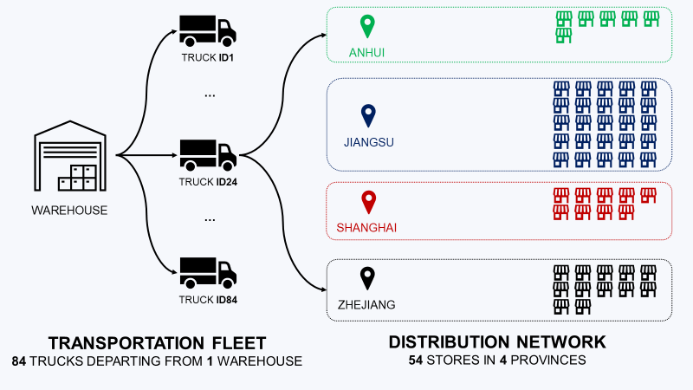

FIG: Optimized Transport

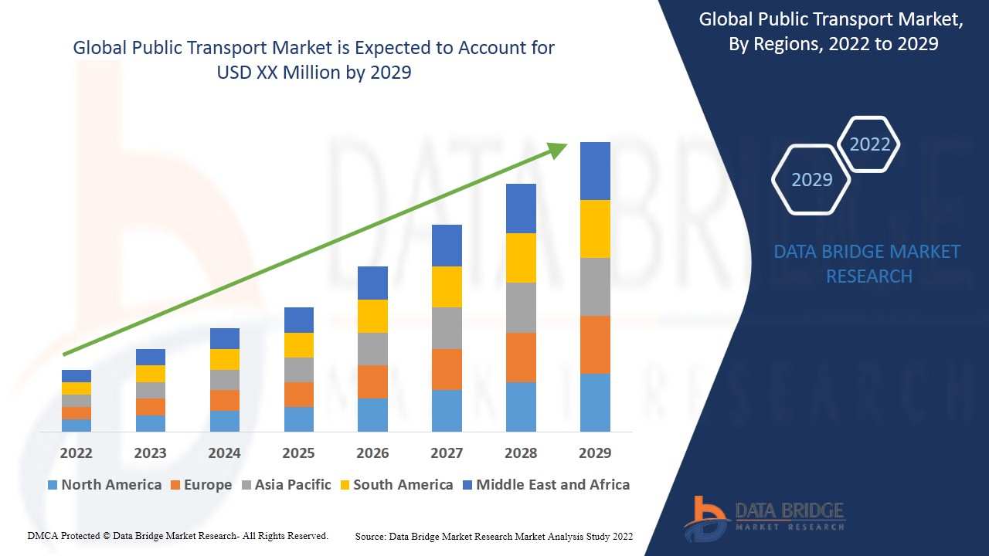

Fig: Public Transport Optimized